Suggested Solution to Assignment about Chapter 4 Probability

- Multiple Choice Questions (For every question there is only one correct choice. Please circle it.)
(1) Two mutually exclusive events having positive probabilities are ______________ dependent.
A. Always
B. Sometimes
C. Never
(2) ___________________ is a measure of the chance that an uncertain event will occur.
A. Random experiment
B. Sample Space
C. Probability
D. A complement
E. A population
(3) In which of the following are the two events A and B, always independent?
A. A and B are mutually exclusive
B. The probability of event A is not influenced by the probability of event B
C. The intersection of A and B is zero
D. P(A|B)=P(A)
E. B and D
(4) If two events are independent, we can _____ their probabilities to determine the intersection probability.
A. Divide
B. Add
C. Multiply
D. Subtract
(5) Events that have no sample space outcomes in common and therefore, cannot occur simultaneously are:
A. Independent
B. Mutually Exclusive
C. Intersections
D. Unions
(6) If events A and B are independent, then the probability of simultaneous occurrence of event A and event B can be found with:
A. P(A)·P(B)
B. P(A)·P(B|A)
C. P(B)·P(A|B)
D. All of the above are correct
- Two randomly selected grocery store patrons are each asked to take a blind taste test and to then state which of the three diet colas (marked as A, B, or C) he or she prefers.
(a) (Optional) Draw a tree diagram depicting the sample space outcomes for the test results.
(b) List the sample space outcomes that corresponding to each of the following events.
(1) Both patrons prefer diet cola A.
(2) The two patrons prefer different diet colas.
(3) Diet cola A is preferred by at least one of the two patrons.
(4) Neither of the patrons prefers diet cola C.
(c) Assuming that all sample space outcomes are equally likely, find the probability of each of the events given in part b.
Ans:
(a)
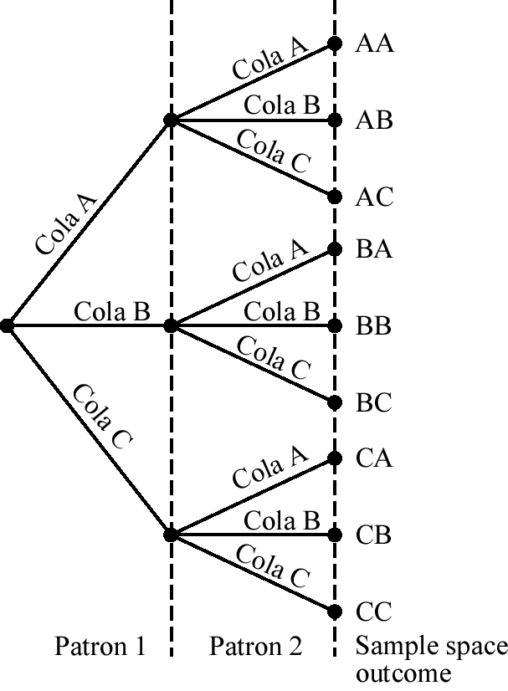
(b) (1) AA
(2) AB, AC, BA, BC, CA, CB
(3) AA, AB, AC, BA, CA
(4) AA, AB, BA, BB
(c) Each outcome has probability 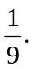
(1) Pr(AA)=
(2) Pr(AB, AC, BA, BC, CA, CB)=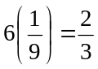
(3) Pr(AA, AB, AC, BA, CA)=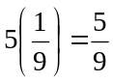
(4) Pr(AA, AB, BA, BB)=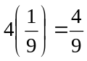
- The U.S. Census Bureau compiles data on family income and summarizes it’s findings in Current Population Reports. The table below is a frequency distribution of the annual incomes for a random sample of U.S. families. Find an estimate of the probability selected U.S. family has an income between $60,000 and $199, 999.
Income | Frequency (in thousands)
Under $20,000 | 11,470
$20,000-$39,999 | 17,572
$40,000-$59,999 | 14,534
$60,000-$79,999 | 11,410
$80,000-$99,999 | 7,535
$100,000-$199,999 | 11,197
$120,000 and above | 2,280
Total | 75,998

Ans:
Probability = (11410 + 7535 + 11197) / 75998 = 30142 / 75998 = 0.397
- A survey of top executives revealed that 35 percent of them regularly read Time magazine, 20 percent read Newsweek, and 40 percent read U.S. News and World Report. Ten percent read both Time and U.S. News and World Report.
(a) What is the probability that a particular top executive reads either Time or U.S. News and World Report?
(b) What is the probability 0.10 called?
(c) Are the events mutually exclusive? Explain.
Ans:
(a) Let T and U denote Time and U.S. News and World Report respectively.
P(T or U) =P(T) +P(U) – P(T∩U)=0.35+0.40 – 0.10=0.65
(b) It is the joint probability.
(c) No, an executive could read more than one magazine.
- Independently a coin is tossed, a card is drawn from a deck and a die is thrown. What is the probability of observing a head on the coin, an ace on the card and a five on the die? (Hint: There are total 52 cards in a deck.)
Ans: Denote the events of observing a head on the coin, an ace on the card and a five on the die as A, B, and C respectively. Then A, B and C are independent. Thus,
Pr(A∩B∩C)= P(A) P(B)P(C)
=1/2*4/52*1/6=1/156
- Joe is considering pursuing an MBA degree. He has applied to two different universities. The acceptance rate for applicants with similar qualifications is 25% for University A and 40% for University B. What is the probability that Joe will be accepted at least by one of the two universities?
Ans: Define the following events:
S= Joe will be accepted at least by one of the two, or {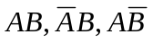}
F= Joe will not be accepted by any universities, or {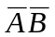}
Obviously, F is the complement of S.
P(S)=1-P(F)=1-P()=1 – P(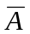)P(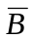)=1 –[1- P(A)][1-P(B)]= 1-[(.75)(.60)]=0.55
- The Wood County sheriff classifies crimes by age (in years) of the criminal and whether the crime is violent or nonviolent. As shown below, a total of 150 crimes were reported by the sheriff last year.
 | Age (in years)
Type of crime | Under 20 | 20 to 40 | Over 40 | Total
Violent | 27 | 41 | 14 | 82
Nonviolent | 12 | 34 | 22 | 68
Total | 39 | 75 | 36 | 150
(a) What is the probability of selecting a case to analyze and finding it involved a violent crime?
(b) What is the probability of selecting a case that involved a violent crime or an offender less than 20 years old? Which rule of additional did you apply?
(c) Given that a violent crime is selected for analysis, what is the probability the crime was committed by a person under 20 years old?
(d) (Optional) Two crimes are selected for review by Judge Tybo. What is the probability that both are violent crimes?
Ans:
(a) P(Violent)=82/150=0.5467
(b) P(Violent or less than 20 years old)= 82/150+39/150-27/150=0.6267 (Additional rule)
(c) P(Under 20 |Violent)= P(Under 20 ∩Violent)/ P(Violent)=27/82=0.3293
(d) P(1st Violent and 2nd Violent)= P(1st Violent )P(2nd Violent|1st Violent)
= (82/150)(81/149)=0.2972
- In a survey of 100 insurance claims, 40 are fire claims (FIRE), 16 of which are fraudulent (FRAUD). Also, there are a total of 40 fraudulent claims.
(a) Construct a contingency table summarizing the claims data. Use the pairs of events FIRE and 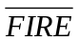, FRAUD and 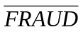.
(b) What proportion of the fire claims are fraudulent?
(c) Are the events a claim is fraudulent and a claim is fire claim independent? Use your probability of part b to prove your answer?
Ans:(a) Fire Total
Fraud 16 24 40
24 36 60
Total 40 60 100
(b) 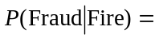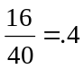
(c) Yes; = P(Fraud)

- Suppose that A1, A2, and B are events where A1 and A2 are mutually exclusive and
P(A1)=0.8, P(B|A1)= 0.1, P(A2)=0.2, P(B|A2)=0.3.
Use this information to find P(B), P(A1|B) and P(A2|B).
Ans: P(B)= P(A1)P(B|A1)+P(A2)P(B|A2)= (0.8)( 0.1)+(0.2)(0.3)=0.14,
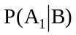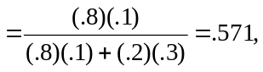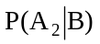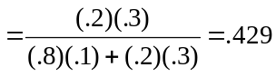
- A department store is considering a new credit policy to reduce the number of customers defaulting in payments. A suggestion is made to discontinue credit to any customer who has been one week or more late with his/her payment at least twice. Past records show 95 percent of defaults were late at least twice. Also, 3 percent of all customers default, and 30 percent of those who have not defaulted had at least two late payments.
(a) Find the probability that a customer with at least twice late payments will default.
(b) Based on part a, should the policy be adopted? Explain.
Ans:
(a) P(default⏐late) 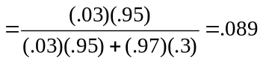
(b) No. Too many paying customers would lose credit.

